Table of Contents

1.0 Section 1 2

1.1 Introduction to the Web Application 2

1.2 Product Backlog and User Stories 4

1.3 Detailed User Stories with Acceptance Criteria 7

2.0 Section 2 20

2.1 UML Design 20

2.1.1 Class Diagram 20

2.1.2 Use Case Diagram 21

2.1.3 Activity Diagram 22

2.2 Screen Design 26

2.2.1 Faulty Facility Report 26

2.2.2 Work Confirmation 30

2.2.3 Comment 33

3.0 Section 3 38

3.1 Test Scenario, Test Plan and Test Data 38

3.1.1 Blackbox Testing 38

3.1.2 Brief Description 43

# 1.0 Section 1

## 1.1 Introduction to the Web Application

The online campus facility report system is a new web-based application system that designed to support all faculty members as well as students in making report on faulty facilities in the campus. The system goal is to achieve on creating campus environment that is safer and efficient where the facilities is in good condition by providing the report management. To illustrate that, the features of the system included login as different roles, logout, faulty facility report with adding photo and audio description as attachment to the report, work confirmation for confirming the maintenance is started for the submitted report, job status for informing the progress on the confirmed work, acknowledgement on submitted reports, comment on work confirmation, summary report for maintenance completion, and fault severeness for indicating the priority of the maintenance. Moreover, the roles supported in the system included administrator, faculty member and student. Following that, the development methodology chosen for developing the online campus facility report system based on the requirements is Agile development methodology, Scrum as specific. The reason of choosing Scrum methodology is due to its excellent capability in handling complex system. To elaborate that, the complexity of online campus facility report system is raised due to its requirements consists of multiple features and multiple roles. Moreover, another reason of using Scrum methodology for the system development is due to its iterative approach, sprints, which make it possible for adaptation and continuous improvement as the feedback from the stakeholders is considered for the subsequent sprints. In addition, another reason of selecting Scrum methodology is due to its fast development. To elaborate that, it allows this new system to deliver quickly and efficiently for user testing. Finally, Scrum methodology is selected because it is able to divide this large project into smaller sprints. Hence, making the project more manageable. *Table 1.1* shows the summary of the introduction to the online campus facility report system.

|  |  |
| --- | --- |
| **System:** | Online Campus Facility Report System |
| **System Type:** | Web-Based Application |
| **System Goal:** | Create safer campus with efficient facility that is in good condition by providing faulty facility report system. |
| **Features** | * Login * Logout * Faulty Facility Report * Work Confirmation * Job Status * Acknowledgment * Comment * Summary Report * Fault Severeness |
| **User Roles:** | * Administrator * Faculty Member * Student |
| **Software Development Methodology:** | Scrum (Agile Software Development) |
| Reason:   * Excellent in handling complex system. * Iterative approach (sprints) for adaptation and continuous improvement. * Fast deliverables on the product. * Dividing large project into smaller manageable pieces. |

*Table 1.1* Summary Table of Online Campus Facility Report System

Moreover, due to the fact that some of the roles share the same features, hence the roles will be generalise as shown in *Figure 1.1*.

*Figure 1.1* Roles Generalisation

*Table 1.2* shows the more detailed scopes of the software.

|  |  |  |
| --- | --- | --- |
|  | **Features** | **Description** |
| 1. | Login | * User should be able to login to their account and access the system with their respective role privileges. |
| 2. | Logout | * User should be able to logout their account. |
| 3. | Faulty Facility Report | * Fault Reporter should be able to submit report on faulty facility with photo and audio description as attachment. * Administrator should be able to view the submitted report for reviewing. |
| 4. | Work Confirmation | * Administrator should be able to send work confirmation to inform about the work details that will be constructed during the maintenance on the report. For example, maintenance start date and time, expected end date and time, and the work listing. * Fault Reporter should be able to receive work confirmation to be informed about the work is confirmed on their submitted report along with the work details will be constructed during the maintenance. For example, maintenance start date and time, expected end date and time, and the work listing. |
| 5. | Job Status | * Administrator should be able to update the job status to inform the work progress on the ongoing maintenance on the report. * Fault Reporter should be able to view job status to be informed about the work progress on the ongoing maintenance. |
| 6. | Acknowledgement | * Administrator should be able to send acknowledgement to inform the faulty facility report is reviewed and the attitude towards the report such as the maintenance is rejected due to false information, or it is accepted and will notify once the work is confirmed. * Fault Reporter should be able to receive acknowledgement to be informed on the submitted report have been reviewed and the attitude towards the report such as the maintenance is rejected due to false information, or it is accepted and will notify once the work is confirmed. |
| 7. | Comment | * Faculty Member should be able to add comment and reply comment on the work confirmation, as having more responsibility to communicate on the maintenance and work arrangement. * Administrator should be able to reply comment on the work confirmation to address concern of the maintenance and work arrangement. |
| 8. | Summary Report | * Administrator should be able to send summary report to inform on completed maintenance. * Fault Reporter should be able to view the summary report and get informed on completed maintenance. |
| 9. | Fault Severeness | * Fault Reporter should be able to submit report as severe fault to indicate the maintenance priority. * Administrator should be able to view on severe fault report to prioritise the maintenance arrangement. |

*Table 1.2* Online Campus Facility Report System Software Scopes

## 1.2 Product Backlog and User Stories

For clarification, the first sprint, Sprint 1 has finished on developing Feature 1 and Feature 2, which is Login and Logout. Hence, the updated product backlog after Sprint 1, consisting overall features with short summary of user stories are shown in *Table 1.1*. Due to the reason that this is a new system instead of updating an existing system, and only 1 sprint is done with no improvement required, hence there will not be having the column ‘Type’ as the value held will be repeated as ‘Requirement’, resulting in wastage on the table space. Moreover, the priority of the features is indicated as a number is due to the purpose of referring it as the development order number. The reason is that it is nearly impossible for features to be develop exactly the same time even though that have similar priority. In addition, the reason for consolidating the features for Administrator side and for Faculty Member side is that only 3 features will be selected on Sprint 2, hence, to show the functionality for all three roles, those features from both sides are considered as one feature but with different user stories.

|  |  |  |  |  |  |  |
| --- | --- | --- | --- | --- | --- | --- |
|  | **Features** | **User Stories** | **ID** | **Priority** | **Status** | **Estimate** |
| 1. | Login | As a User, I want to authenticate myself and login, so that I can access the system with my respective role privileges. | 1 | 1 | Done | 3 |
| 2. | Logout | As a User, I want to logout, so that I can terminate my session securely. | 2 | 2 | Done | 1 |
| 3. | Faulty Facility Report | As a Fault Reporter, I want to report faulty facility with photo and audio description attachment, so that I can inform the fault clearer. | 3 | 3 | Not Started | 11 |
| As an Administrator, I want to view all the faulty facility report made, so that I can review the report and decide on action. | 4 | 4 | Not Started | 9 |
| 4. | Work Confirmation | As an Administrator, I want to send work confirmation with the details of works will be constructed, so that I can inform about the maintenance work is arranged for the report. | 5 | 5 | Not Started | 9 |
| As a Fault Reporter, I want to view the confirmed work on submitted report with the details of works will be constructed, so that I knows that my report will be started to work on with detailed information. | 6 | 6 | Not Started | 7 |
| 5. | Job Status | As an Administrator, I want to update the job status, so that I can inform the maintenance progress. | 7 | 9 | Not Started | 5 |
| As a Fault Reporter, I want to view the job status, so that I can know the maintenance progress. | 8 | 10 | Not Started | 5 |
| 6. | Acknowledge-ment | As an Administrator, I want to send the acknowledgement, so that I can inform the report is reviewed along with the attitude towards the report with reason. | 9 | 11 | Not Started | 4 |
| As a Fault Reporter, I want to view the acknowledgement of my submitted report, so that I can know if my maintenance report is approved or rejected with reason. | 10 | 12 | Not Started | 3 |
| 7. | Comment | As a Faculty Member, I want to add comment and reply comment on the work confirmation, so that I can be more responsible on provide feedback and communicate about the maintenance and work arrangement. | 11 | 7 | Not Started | 10 |
| As an Administrator, I want to reply comment on the work confirmation, so that I can address concern on the maintenance and work arrangement. | 12 | 8 | Not Started | 6 |
| 8. | Summary Report | As an Administrator, I want to send summary report, so that I can inform on completed maintenance with details given. | 13 | 13 | Not Started | 9 |
| As a Fault Reporter, I want to view the summary report on completed maintenance, so that I can know that the maintenance is done with details given. | 14 | 14 | Not Started | 5 |
| 9. | Fault Severeness | As a Fault Reporter, I want to submit report as severe fault, so that my report will get the priority for maintenance. | 15 | 15 | Not Started | 6 |
| As an Administrator, I want to view severe fault report, so that I can prioritise the maintenance arrangement on that report. | 16 | 16 | Not Started | 7 |

*Table 1.3* Product Backlog and User Stories

To explain on the priority set, Feature 3, Feature 4, and Feature 7, which is Faulty Facility Report, Work Confirmation and Comment features is prioritised as they are the main features of the system. To illustrate that, Feature 3: Faulty Facility Report feature support the main goal of the system, which enabling all faculty members and students to report faulty facilities. Next, having the Feature 4: Work Confirmation feature enable the fault reporter, which including faculty member and student to know their report is acknowledged with more information such as the work in confirmed with maintenance start date and work listing, while Feature 6: Acknowledgement just inform them about the attitude towards the report. Hence, in order to test the usability of the system, Feature 4: Work Confirmation provide more values. Moving forward, Feature 7: Comment is prioritised as it differentiates the privileges on Faculty Member and Student role, where Faculty Member have more responsibilities in ensuring the maintenance work on the right track such as the work listing for the maintenance is correct and communicating on shifting the maintenance start date to earlier time as if it is urgent. Hence, prioritising this feature as one of the main features can test the usability of the system in earlier stage in case there is adaptation or improvement needed. The other features are relatively less prioritised as they are just additional features to support and enhance the main features of the online campus facility report system, hence leaving them in the upcoming sprints is adequate and more appropriate.

Therefore, according to the priority, Feature 3, Feature 4 and Feature 7 is selected as the work items for the next sprint, which is Sprint 2. For clarification, the following report will only be focusing on Sprint 2, hence, the features developed in Sprint 1 will not be presented in this report. The workflow is shown in *Figure 1.2* with the annotation for better clarification. The details on user stories for Sprint 2 will be shown in the next section.

Current

Sprint

Previous

Sprint

*Figure 1.2* Workflow of the System

## 1.3 Detailed User Stories with Acceptance Criteria

Due to the reason that some of the user stories for the selected features are considered huge, hence they will be split into smaller user stories as making the task more manageable. In addition, as for clarification, the priority and estimate here is referring to the priority and estimate of time in this Sprint 2.

**Sprint 2 User Stories:**

**Feature 3: Faulty Facility Report‎‎‎‎‎**

Before Split:

|  |  |
| --- | --- |
| ID: 3 | As a Fault Reporter, I want to report faulty facility with photo and audio description attachment, so that I can inform the fault clearer. |

After Split:

|  |  |  |
| --- | --- | --- |
| **Title:**  User Story 1 – Constant Information Fill In by Default | **Priority:**  Medium | **Estimate:**  3 |
| **User Story**  **As a** Fault Reporter,  **I want to** fill in the information that stays the same for every report by default,  **so that I can** directly fill in the other required details. | | |
| **Acceptance Criteria**  **Given that** the Fault Reporter enters correct credentials,  **when** the Fault Reporter selects <*login*> option,  **then** the system directs the Fault Reporter to the home page, fault report,  **and** displays the report form with email, id, role, and name of the Fault Reporter filled in by default. | | |

|  |  |  |
| --- | --- | --- |
| **Title:**  User Story 2 – Submit Fault Report | **Priority:**  High | **Estimate:**  3 |
| **User Story**  **As a** Fault Reporter,  **I want to** submit report about the fault,  **so that I can** inform about the issue. | | |
| **Acceptance Criteria**  **Given that** the Fault Reporter login the system with correct credentials,  **and** been directed to the home page, fault report,  **when** the Fault Reporter enters valid required details, including mobile number, location, defective item, and description in the fault report form,  **and** selects <s*ubmit*> option,  **then** the system sends the report to the Administrator,  **and** the system prompts the Fault Reporter for successful submission along with system generated report id. | | |

|  |  |  |
| --- | --- | --- |
| **Title:**  User Story 3 – Invalid and Missing Details for Report | **Priority:**  High | **Estimate:**  1 |
| **User Story**  **As a** Fault Reporter,  **I want to** get remind on invalid and missing details,  **so that I can** submit all required information to help in the fault report review process. | | |
| **Acceptance Criteria**  **Given that** the Fault Reporter enters some invalid or missing details in the fault report form,  **when** the Fault Reporter selects <s*ubmit*> option,  **then** the system prompts the Fault Reporter on the invalid or missing details,  **and** the fault report is not submitted,  **then** the Fault Reporter can make respective adjustment before submission | | |
| **Title:**  User Story 4 – Add Photo Attachment | **Priority:**  Medium | **Estimate:**  2 |
| **User Story**  **As a** Fault Reporter,  **I want to** add photo as attachment to the fault report,  **so that I can** inform and show the issue in more detailed way. | | |
| **Acceptance Criteria**  **Given that** the Fault Reporter login the system with correct credentials,  **and** been directed to the home page, fault report,  **when** the Fault Reporter selects <*browse photo*> option,  **then** the system prompts the Fault Reporter to upload image format file,  **given that** the Fault Reporter browse through the folders,  **when** the Fault Reporter uploads image format file,  **then** the system displays the uploaded image with file name in the photo section to indicate the selected photo is added. | | |

|  |  |  |
| --- | --- | --- |
| **Title:**  User Story 5 – Add Audio Attachment | **Priority:**  Medium | **Estimate:**  2 |
| **User Story**  **As a** Fault Reporter,  **I want to** add audio description as attachment to the fault report,  **so that I can** inform the issue clearer. | | |
| **Acceptance Criteria**  **Given that** the Fault Reporter login the system with correct credentials,  **and** been directed to the home page, fault report,  **when** the Fault Reporter selects <*browse audio*> option,  **then** the system prompts the Fault Reporter to upload audio format file,  **given that** the Fault Reporter browse through the folders,  **when** the Fault Reporter uploads audio format file,  **then** the system displays the uploaded audio with file name and allow playback in the audio section to indicate the selected audio is added. | | |

Before split:

|  |  |
| --- | --- |
| ID: 4 | As an Administrator, I want to view all the faulty facility report made, so that I can review the report and decide on action. |

After split:

|  |  |  |
| --- | --- | --- |
| **Title:**  User Story 6 – Receive Fault Report | **Priority:**  High | **Estimate:**  5 |
| **User Story**  **As an** Administrator,  **I want to** receive all faulty facility reports made,  **so that I can** access to the report and review. | | |
| **Acceptance Criteria**  **Given that** the Administrator enters correct credentials,  **when** the Administrator selects <*login*> option,  **then** the system directs the Administrator to the home page, fault report,  **and** displays all the report submission sent to the Administrator. | | |
| **Title:**  User Story 7 – View Fault Report Details | **Priority:**  High | **Estimate:**  4 |
| **User Story**  **As an** Administrator,  **I want to** view all the details of the fault report made,  **so that I can** review the report and decide on action. | | |
| **Acceptance Criteria**  **Given that** the Administrator login the system with correct credentials,  **and** been directed to the home page, fault report,  **and** the Administrator have received at least one report,  **when** the Administrator selects one of the submitted report,  **then** the system displays all the information of that report for the Administrator to review. | | |

**Feature 4: Work Confirmation**

Before Split:

|  |  |
| --- | --- |
| ID: 5 | As an Administrator, I want to send work confirmation with the details of works will be constructed, so that I can inform about the maintenance work is arranged for the report. |

After Split:

|  |  |  |
| --- | --- | --- |
| **Title:**  User Story 8 – Fill in Confirmed Work Details | **Priority:**  High | **Estimate:**  3 |
| **User Story**  **As an** Administrator,  **I want to** fill in confirmed work details,  **so that I can** provide more details on the maintenance arrangement. | | |
| **Acceptance Criteria**  **Given that** the Administrator selects on one report in the home page, fault report,  **and** reviews the report,  **and** the maintenance work is arranged,  **when** the Administrator selects <*confirm work*> option,  **then** the system navigates the Administrator to the send work confirmation page,  **and** display the form for Administrator to fill in the details of the maintenance. | | |

|  |  |  |
| --- | --- | --- |
| **Title:**  User Story 9 – Send Work Confirmation | **Priority:**  High | **Estimate:**  5 |
| **User Story**  **As an** Administrator,  **I want to** send work confirmation,  **so that I can** inform that maintenance work is arranged for the report. | | |
| **Acceptance Criteria**  **Given that** the Administrator selects <*confirm work*> option on a report,  **and** been navigated to the send work confirmation page,  **and** fills in valid required maintenance details, including maintenance start date and time, expected end date and time, and work listing,  **when** the Administrator selects <*submit*> option,  **then** the system sends the work confirmation to the Fault Reporter of that report,  **and** the system prompts the Administrator for successful work confirmation sent along with system generated work id. | | |

|  |  |  |
| --- | --- | --- |
| **Title:**  User Story 10 – Invalid and Missing Details for Work Confirmation | **Priority:**  High | **Estimate:**  1 |
| **User Story**  **As an** Administrator,  **I want to** get remind on invalid and missing details,  **so that I can** ensure all details on the maintenance arrangement are informed. | | |
| **Acceptance Criteria**  **Given that** the Administrator enters some invalid or missing details in the work confirmation form,  **when** the Administrator selects <*submit*> option,  **then** the system prompts the Administrator on the invalid or missing details,  **and** the work confirmation is not sent,  **then** the Administrator can make respective adjustment before sending the work confirmation. | | |

Before Split:

|  |  |
| --- | --- |
| ID: 6 | As a Fault Reporter, I want to view the confirmed work on submitted report with the details of works will be constructed, so that I knows that my report will be started to work on with detailed information. |

After Split:

|  |  |  |
| --- | --- | --- |
| **Title:**  User Story 11 – Receive Work Confirmation | **Priority:**  High | **Estimate:**  3 |
| **User Story**  **As a** Fault Reporter,  **I want to** receive work confirmation for confirmed maintenance on the report I submitted,  **so that I can** know that maintenance of my report is being worked on. | | |
| **Acceptance Criteria**  **Given that** the Fault Reporter login in the system with correct credentials,  **when** the Fault Reporter selects <*confirmed work*> option on the sidebar menu,  **then** the system directs the Fault Reporter to the confirmed work page,  **and** displays all the work confirmation sent to the Fault Reporter. | | |
| **Title:**  User Story 12 – View Work Confirmation Details | **Priority:**  High | **Estimate:**  4 |
| **User Story**  **As a** Fault Reporter,  **I want to** view all the details of a work confirmation,  **so that I can** know the detailed information on the maintenance arrangement. | | |
| **Acceptance Criteria**  **Given that** the Fault Reporter selects <*confirmed work*> option on the sidebar menu,  **and** been directed to the confirmed work page,  **and** have received at least one work confirmation,  **when** the Fault Reporter selects one of the work confirmations,  **then** the system displays all the information of the selected work confirmations. | | |

**Feature 7: Comment**

Before Split:

|  |  |
| --- | --- |
| ID: 11 | As a Faculty Member, I want to add comment and reply comment on the work confirmation, so that I can be more responsible on provide feedback and communicate about the maintenance and work arrangement. |

After Split:

|  |  |  |
| --- | --- | --- |
| **Title:**  User Story 13 – Add Comment | **Priority:**  Medium | **Estimate:**  4 |
| **User Story**  **As a** Faculty Member,  **I want to** add comment on a work confirmation,  **so that I can** provide feedback on the maintenance and work arrangement. | | |
| **Acceptance Criteria**  **Given that** the Faculty Member selects one of the work confirmations,  **when** the Faculty Member enters comment in the text box in the comment section of the selected work confirmation,  **and** selects <*add comment*> option,  **then** the system will submit the comment,  **and** display the submitted comment under the comment section of the selected work confirmation. | | |

|  |  |  |
| --- | --- | --- |
| **Title:**  User Story 14 – View Reply | **Priority:**  Low | **Estimate:**  3 |
| **User Story**  **As a** Faculty Member,  **I want to** view reply on my comment,  **so that I can** know the feedback on my comment. | | |
| **Acceptance Criteria**  **Given that** the Faculty Member have added comment on a work confirmation,  **and** there is reply on the comment,  **when** the Faculty Member navigates to that work confirmation,  **then** the comment section of that work confirmation displays the Faculty Member comment along with the reply to the comment. | | |

|  |  |  |
| --- | --- | --- |
| **Title:**  User Story 15 – Faculty Member Add Reply to Comment | **Priority:**  Low | **Estimate:**  3 |
| **User Story**  **As a** Faculty Member,  **I want to** add reply to my comment,  **so that I can** add information or communicate with received reply. | | |
| **Acceptance Criteria**  **Given that** the Faculty Member have added comment on a work confirmation,  **and** the Faculty Member navigates to that work confirmation,  **when** the Faculty Member enters reply in the text box in the reply section under the selected comment,  **and** the Faculty Member selects <*add reply*> on the selected comment,  **then** the system will submit the reply,  **and** display the submitted reply in the reply section under the selected comment. | | |

Before Split:

|  |  |
| --- | --- |
| ID: 12 | As an Administrator, I want to reply comment on the work confirmation, so that I can address concern on the maintenance and work arrangement. |

After Split:

|  |  |  |
| --- | --- | --- |
| **Title:**  User Story 16 – View Comment | **Priority:**  Medium | **Estimate:**  3 |
| **User Story**  **As an** Administrator,  **I want to** view the comment on work confirmation,  **so that I can** know the feedback on the work confirmation. | | |
| **Acceptance Criteria**  **Given that** a comment is added on a work confirmation,  **when** the Administrator navigates to that work confirmation,  **then** the comment section of that work confirmation displays all the comment along with the reply to the comment. | | |

|  |  |  |
| --- | --- | --- |
| **Title:**  User Story 17 – Administrator Add Reply to Comment | **Priority:**  Low | **Estimate:**  3 |
| **User Story**  **As an** Administrator,  **I want to** add reply to the comment,  **so that I can** communicate and address the concern on the maintenance and work confirmation. | | |
| **Acceptance Criteria**  **Given that** comment is added on a work confirmation,  **and** the Administrator navigates to that work confirmation,  **when** the Administrator enters reply in the text box in the reply section under the selected comment,  **and** the Administrator selects <*add reply*> on the selected comment,  **then** the system will submit the reply,  **and** display the submitted reply in the reply section under the comment. | | |

# 2.0 Section 2

## 2.1 UML Design

### 2.1.1 Class Diagram

The class diagram will only focus on Sprint 2, the login logout will only appear as a simple login(), logout() operation in user class without any further details.

*Figure 2.1* Class Diagram

### 2.1.2 Use Case Diagram

The use case diagram will only focus on Sprint 2, hence login and logout features are not included.

*Figure 2.2* Use Case Diagram

### 2.1.3 Activity Diagram

The activity diagram will only focus on Sprint 2, hence login and logout are not included.

***Use Case: Submit Faulty Facility Report***

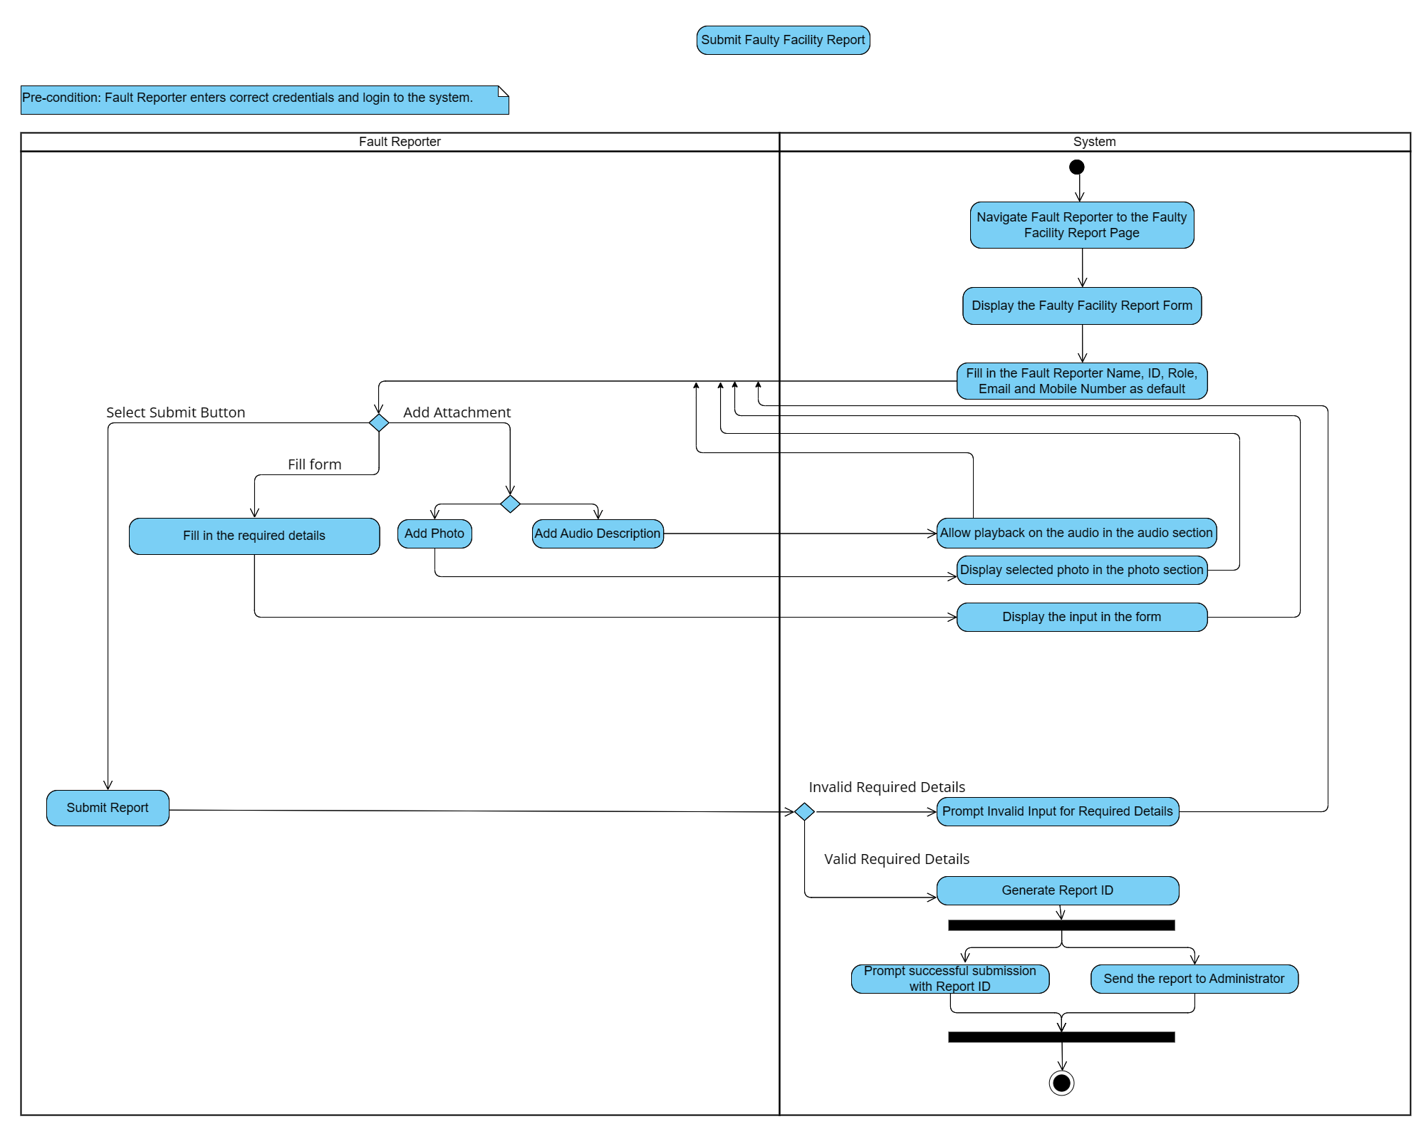

*Figure 2.3* Activity Diagram - Use Case: Submit Faulty Facility Report

***Use Case: View All Work Confirmation Received***

*Figure 2.4* Activity Diagram - Use Case: View All Work Confirmation Received

***Use Case: View All Faulty Facility Report***

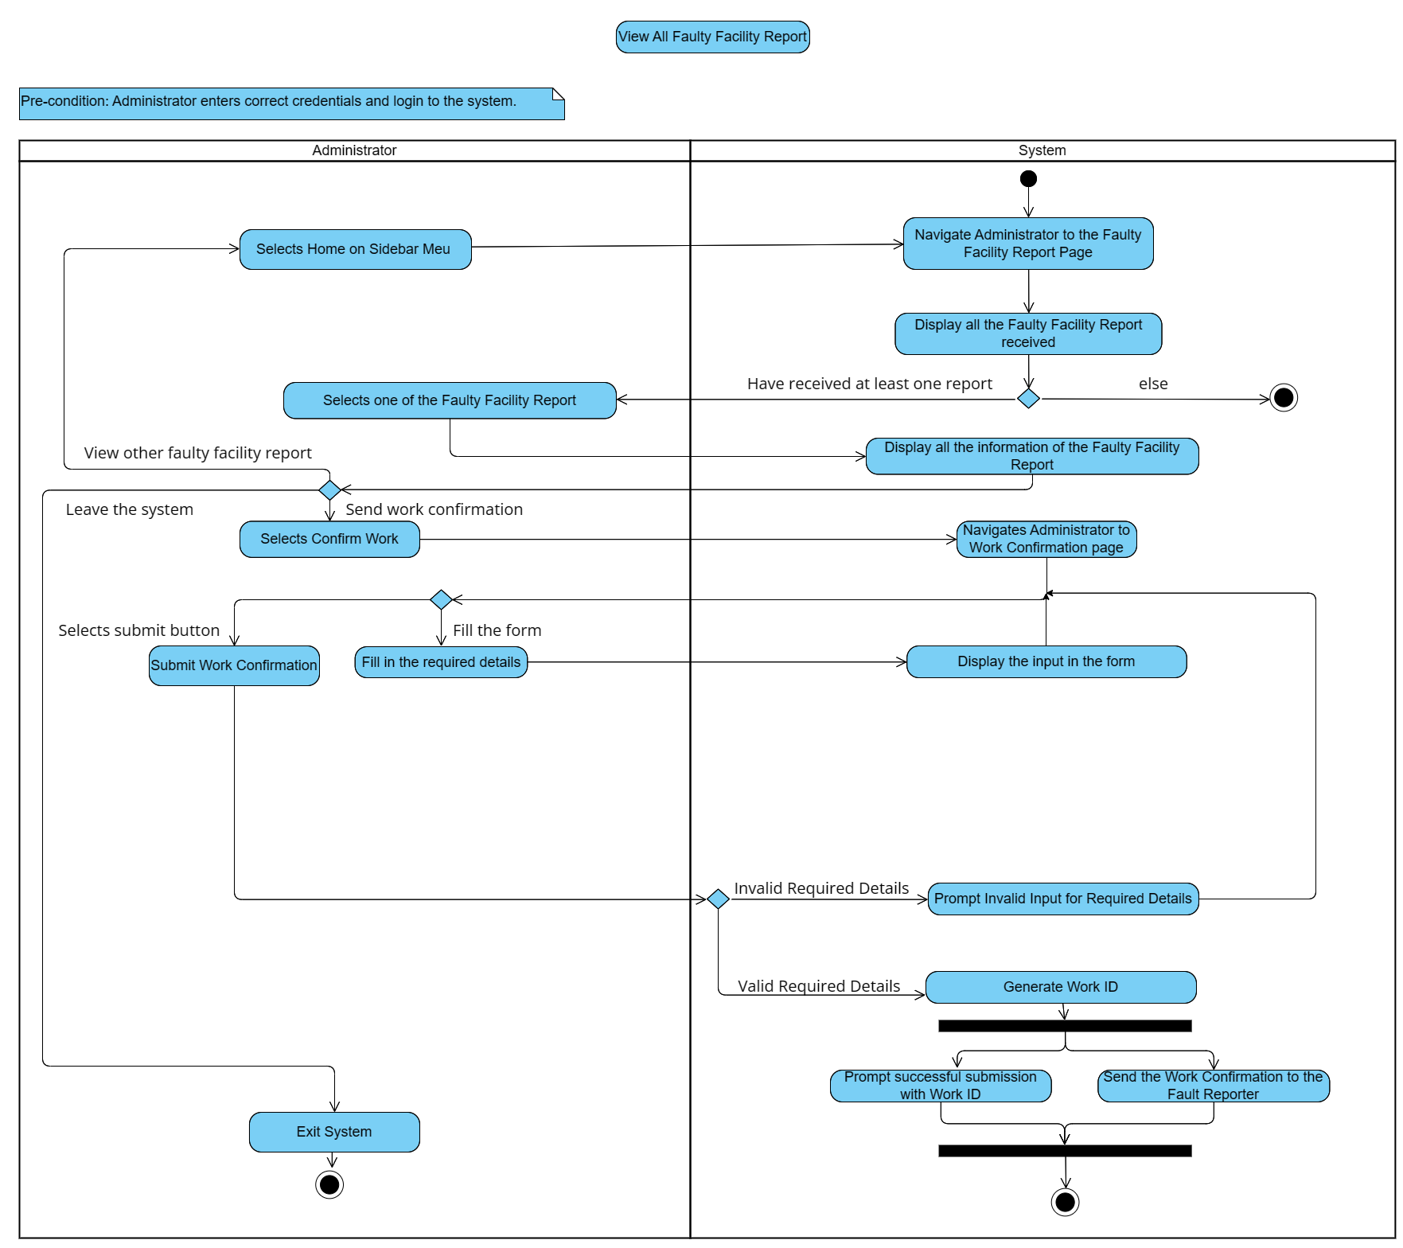

*Figure 2.5* Activity Diagram - Use Case: View All Faulty Facility Report

***Use Case: View All Work Confirmation Sent***

*Figure 2.6* Activity Diagram - Use Case: View All Work Confirmation Sent

## 2.2 Screen Design

### 2.2.1 Faulty Facility Report

**Fault Reporter**

*User Story 1 – Constant Information Fill In by Default*

1. Fault Reporter successfully login, directed to the home page.

1. Information such as Name, ID, Role, Email that will remain same for an account have been filled by default.

*User Story 2 – Submit Fault Report*

2. Clicked on ‘Submit’.

1. All required details marked with ‘*’ have been filled with valid input.

Report ID

1. Display successful submission page along with Report ID for reference.

*User Story 3 – Invalid and Missing Details for Report*

1. Prompt on invalid and missing required details.
2. Clicked on ‘Submit’.

*User Story 4 – Add Photo Attachment*

1. Photo section display ‘2 Files Selected, along with the image preview with the file name.
2. Upload toilet.png and faucet.png.
3. Clicked on ‘Browse Photo’.

*User Story 5 – Add Audio Attachment*

1. Audio section display ‘1 File Selected’ along with the playback button that allow Fault Reporter to listen and the file name.
2. Upload 202403041004.m4a
3. Clicked on ‘Browse Audio’.

**Administrator**

*User Story 6 – Receive Fault Report*

1. Administrator successfully login, directed to the home page.

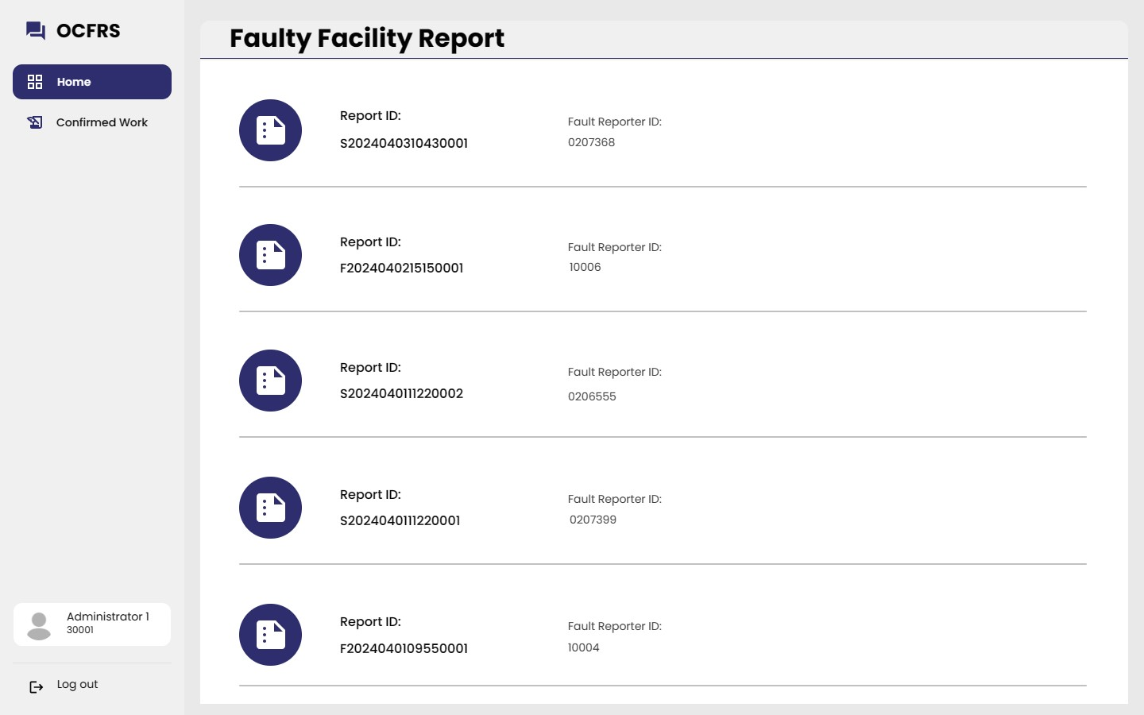

1. Sorted as newest report first.
2. Display along with the Report ID and Fault Reporter ID.
3. Display all received report.

*User Story 7 – View Fault Report Details*

1. Selected one of the fault reports.

1. ‘Confirm Work’ Button to send work confirmation.
2. Display the Faulty Facility’s Information.
3. Display the Fault Reporter’s Information.
4. Attachment.
5. Display the Report ID of the selected fault report.

### 2.2.2 Work Confirmation

**Administrator**

1. Selects ‘Confirm Work’ and directed to work confirmation page for Administrator to fill in details.

*User Story 8 – Fill in Confirmed Work Details*

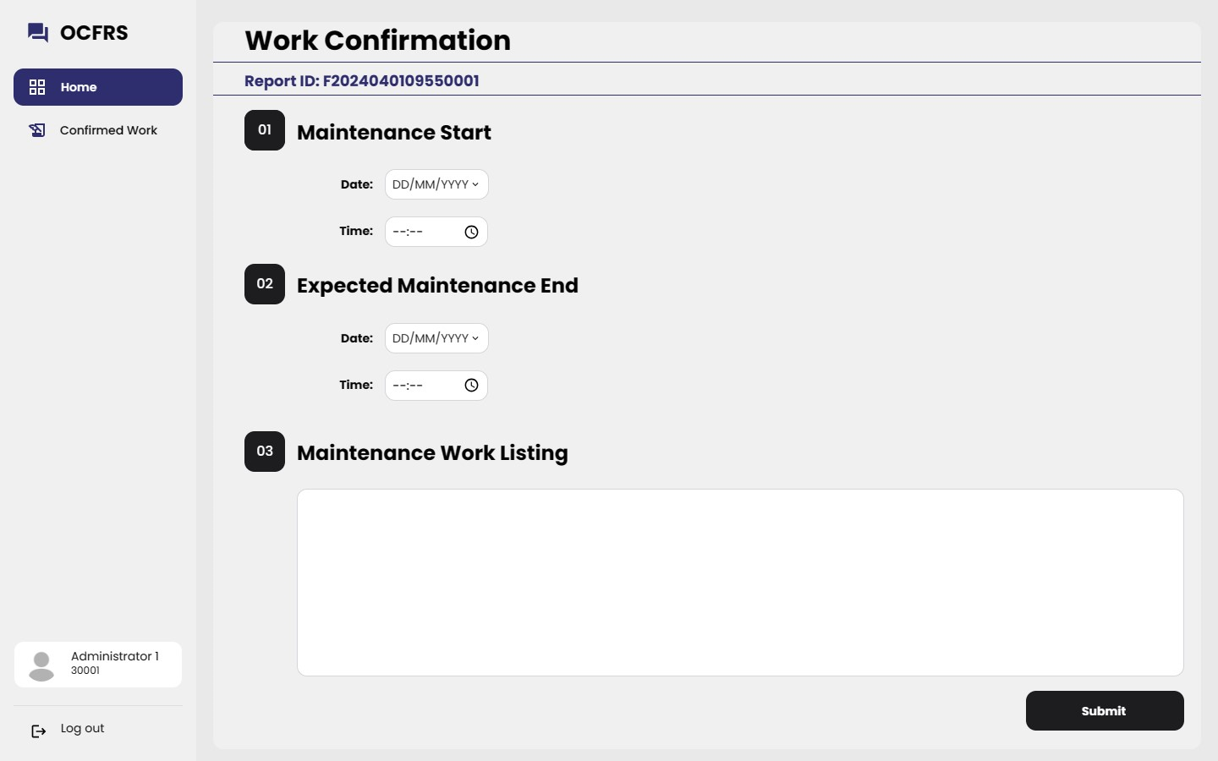

1. Textbox for maintenance work listing.
2. Time picker for start and end time.
3. Date picker for start and end date.
4. Display the Report ID according to the report selected to confirm work.

*User Story 9 – Send Work Confirmation*

1. Clicked on ‘Submit’ button.
2. Filled in with valid details.

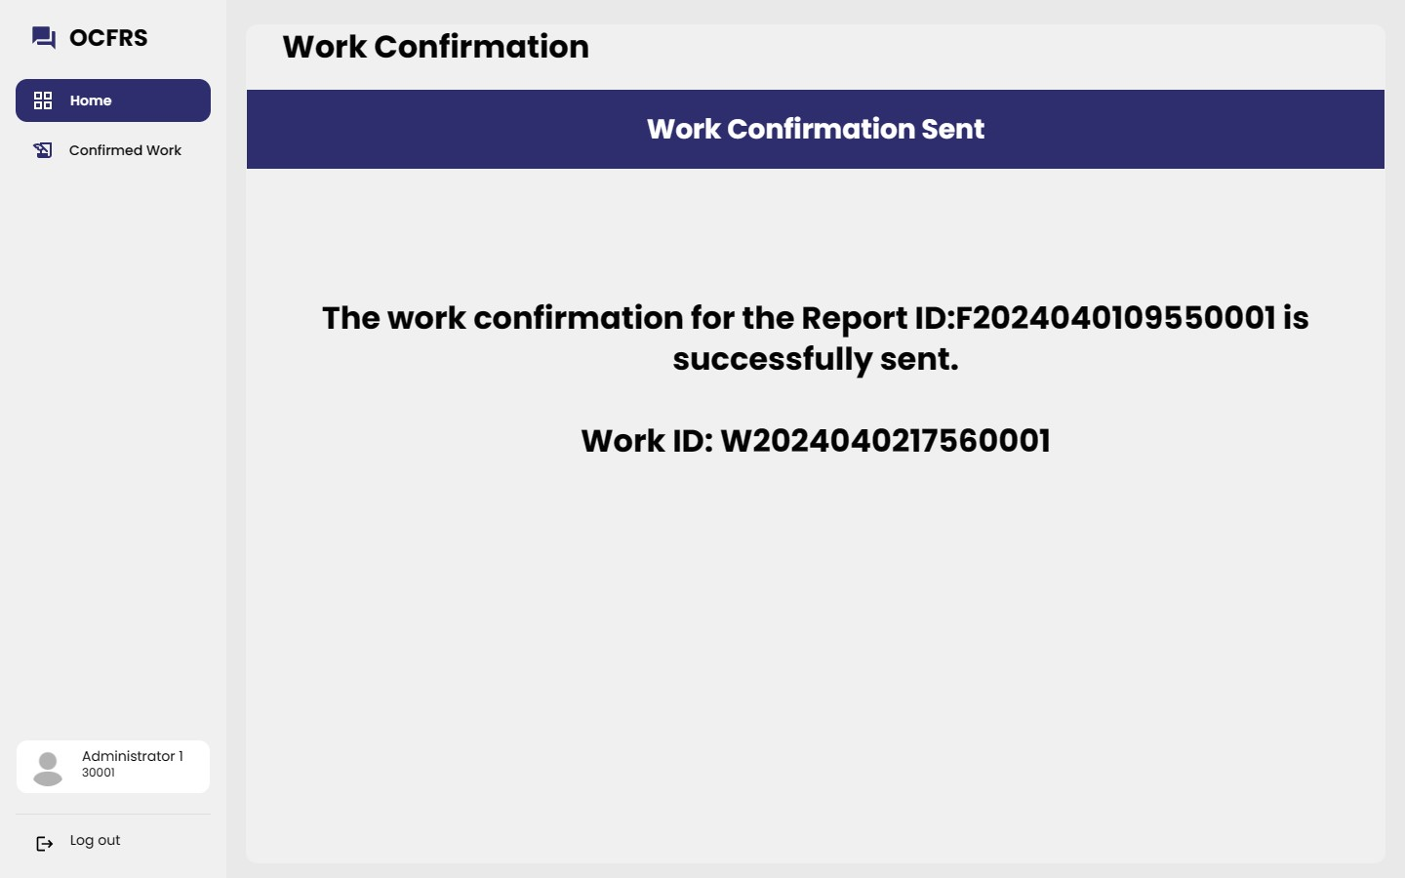

Work ID

Report ID

1. Display successful submission page along with Work ID for reference.

*User Story 10 – Invalid and Missing Details for Work Confirmation*

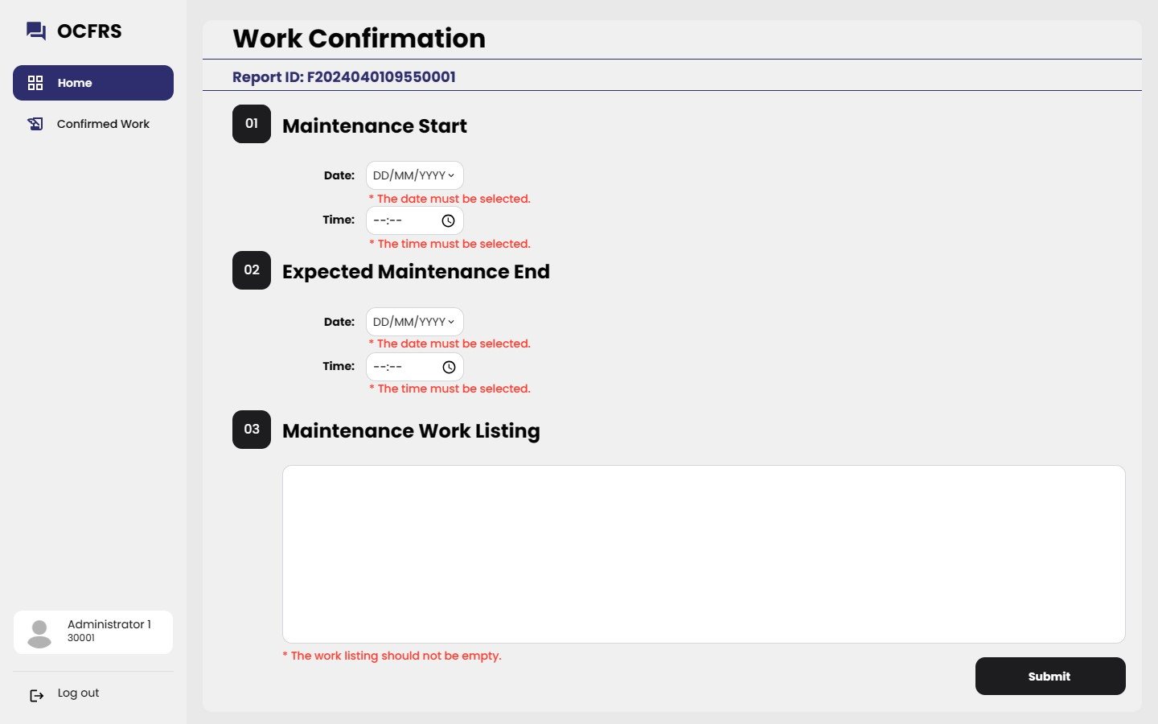

1. Prompt on invalid and missing details.
2. .
3. Clicked on ‘Submit’ button.

**Fault Reporter**

*User Story 11 – Receive Work Confirmation*

Pre-condition: The administrator have sent the work confirmation to the fault reporter.

1. Directed to the confirmed work page.
2. Display along with Work ID and Report ID.
3. Display all the work confirmation received on submitted report.
4. Clicked on ‘Confirmed Work’ on sidebar menu.
5. Selected the work confirmation to view the details.

*User Story 12 – View Work Confirmation Details*

1. Student do not have comment section or add comment feature.
2. Display all the maintenance arrangement details.
3. Display Report ID.
4. Display Work ID.

### 2.2.3 Comment

**Faculty Member**

*User Story 13 – Add Comment*

1. Faculty Member have add comment feature.
2. Faculty Member have comment section.

1. Click on ‘Add Comment’ button.
2. Write comment in the comment text box.

1. Can add other comment.
2. Reply section is open.
3. Comment added.

*User Story 14 – View Reply*

Pre-condition: Administrator have replied to the comment.

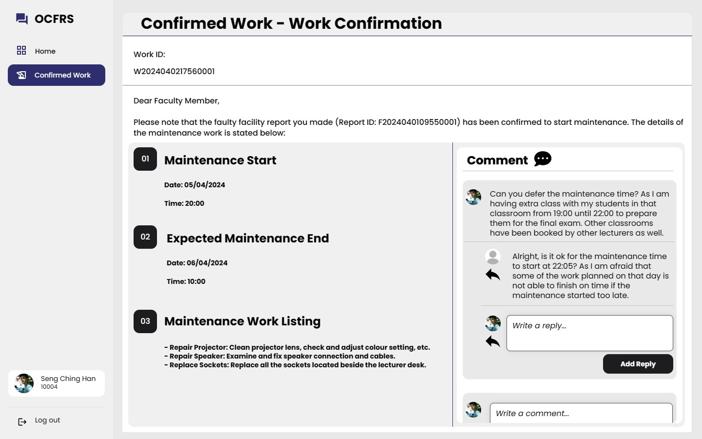

1. The comment section is scrollable.
2. View reply from the Administrator.

*User Story 15 – Faculty Member Add Reply to Comment*

1. Click on ‘Add Reply’ button.
2. Write reply.

1. Reply added.

**Administrator**

*User Story 16 – View Comment*

Pre-condition: Administrator have sent work confirmation.

1. Select on the work confirmations with Faculty Member.
2. Directed to the confirmed work page.
3. Clicked on ‘Confirmed Work’ on sidebar menu.

1. Administrator does not have add comment feature.
2. Display the comment section with the comment by Faculty Member.

*User Story 17 – Administrator Add Reply to Comment*

1. Click on ‘Add Reply’ button.
2. Write reply.

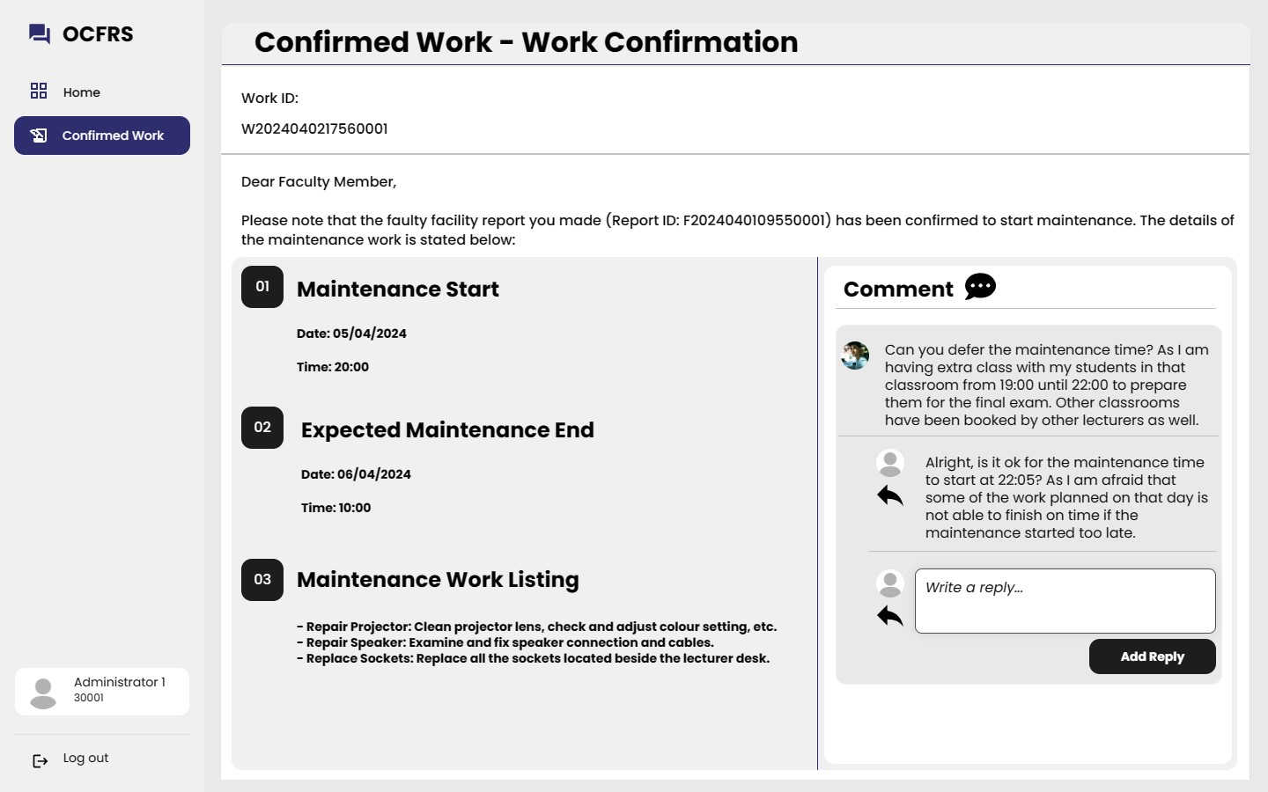

1. Reply added to the comment.

# 3.0 Section 3

## 3.1 Test Scenario, Test Plan and Test Data

Since only submit faulty facility report and submit work confirmation will consist of user input with validation that need to be evaluated, hence Blackbox testing will only include these two use cases. Others which mainly on output will just briefly describe the scenario with expected outcome.

### 3.1.1 Blackbox Testing

***Use Case: Submit Faulty Facility Report* (*Feature 3: Faulty Facility Report*)**

Pre-condition: Fault Reporter logins to the system with correct credentials.

Test Case 1: Mobile No. Validation

|  |  |
| --- | --- |
| Test Scenario: | Verify the Fault Reporter is not able to submit the report when the Mobile No. filled in is invalid. |
| Test Plan: | Unit Testing |

|  |  |  |
| --- | --- | --- |
| Input | Comments | Expected Output |
| 012345678 | Valid Upper Boundary Values | - |
| 0123456789 | Valid Lower Boundary Values | - |
| 01234567890 | Invalid – Above Upper Boundary Values | Prompt ‘The phone number is invalid.’ under the input text box. |
| 01234567 | Invalid – Below Lower Boundary Values | Prompt ‘The phone number is invalid.’ under the input text box. |
| NULL | Invalid – Blank Mobile No. | Prompt ‘The phone number should not be empty’ under the input text box. |
| 012345@@@ | Invalid – Special Characters in Mobile No. | Prompt ‘The phone number is invalid.’ under the input text box. |
| Abc12345 | Invalid – Contain Alphabet | Prompt ‘The phone number is invalid.’ under the input text box. |

*Table 3.1* Mobile No. Test Data

Test Case 2: Location Validation

|  |  |
| --- | --- |
| Test Scenario: | Verify the Fault Reporter is not able to submit the report when the Location filled in is invalid. |
| Test Plan: | Unit Testing |

|  |  |  |
| --- | --- | --- |
| Input | Comments | Expected Output |
| Lecture Hall 2 | Valid Input | - |
| Block B, Level 2, Pink Female Toilet | Valid Upper Boundary Values (30 characters without space) | - |
| Classroom A | Valid Lower Boundary Values (10 Characters without space) | - |
| The female toilet beside male toilet | Invalid – Above Upper Boundary Values | Prompt ‘The location is too long, please be short and precise.’ under the input text box. |
| Man Toilet | Invalid – Below Lower Boundary Values (Explanation: Too short, could not give information, e.g. which toilet) | Prompt ‘The location should be longer to be specific.’ under the input text box. |
| NULL | Invalid – Blank Location | Prompt ‘The location should not be empty.’ under the input text box. |

*Table 3.2* Location Test Data

Test Case 3: Defective Item(s) Validation

|  |  |
| --- | --- |
| Test Scenario: | Verify the Fault Reporter is not able to submit the report when the Defective Item(s) filled in is invalid. |
| Test Plan: | Unit Testing |

|  |  |  |
| --- | --- | --- |
| Input | Comments | Expected Output |
| Projector, Speaker | Valid Input | - |
| Projector, Speaker, Mouse, Computer, Monitor | Valid Upper Boundary Values (40 characters without space) | - |
| Fan | Valid Lower Boundary Values (3 Characters without space) | - |
| The violet monitor ASUS with MG28UQ as model name | Invalid – Above Upper Boundary Values | Prompt ‘The defective item is too long, please be short and precise.’ under the input text box. |
| LG | Invalid – Below Lower Boundary Values (Explanation: Too short, could not give information, e.g. what exactly is that thing branded as LG) | Prompt ‘The defective item should be longer to be specific.’ under the input text box. |
| NULL | Invalid – Blank Defective Item(s) | Prompt ‘The defective item should not be empty.’ under the input text box. |

*Table 3.3* Defective Item(s) Test Data

Test Case 4: Description of Defect(s) Validation

|  |  |
| --- | --- |
| Test Scenario: | Verify the Fault Reporter is not able to submit the report when the Defective Item(s) filled in is invalid. |
| Test Plan: | Unit Testing |

|  |  |  |
| --- | --- | --- |
| Input | Comments | Expected Output |
| The third faucet counting from the left is broken and needs to be replaced. The second and the third toilet counting from left is broken as well. | Valid Input | - |
| [Description with 200 characters without space] | Valid Upper Boundary Values (200 characters without space) | - |
| The fan cannot on. | Valid Lower Boundary Values (15 characters without space) | - |
| [Description with 201 characters without space] | Invalid – Above Upper Boundary Values | Prompt ‘The description of defect is too long, please be short and precise.’ under the input text box. |
| Fan not working. | Invalid – Below Lower Boundary Values (Explanation: Too short, could not give information, e.g. which toilet) | Prompt ‘The description of defect should be longer to provide more information.’ under the input text box. |
| NULL | Invalid – Blank Defect(s) | Prompt ‘The description of defect should not be empty.’ under the input text box. |

*Table 3.4* Description of Defect(s) Test Data

Test Case 5: Successful Submission

|  |  |  |  |
| --- | --- | --- | --- |
| Test Scenario: | | Verify the Fault Reporter is able to submit the faulty facility report when all required details are filled in with valid input. | |
| Test Plan: | | Unit Testing | |
| Field | Input | | Expected Output |
| Mobile No. | 0123456789 | | Prompts for successful submission along with the system generated Report ID for reference. |
| Location | Level 2 – Woman Washroom | |
| Defective Item(s) | Faucet, Toilet | |
| Description of Defect(s) | The third faucet counting from the left is broken and needs to be replaced. The second and the third toilet counting from left is broken as well. | |

*Table 3.5* Test Data for Successful Submission

***Use Case: Submit Work Confirmation* (*Feature 4: Work Confirmation*)**

|  |  |
| --- | --- |
| Pre-condition: | Administrator selects <*confirm work*> option on one of the received faulty facility report. |

Test Case 1: Maintenance Start Date Validation

|  |  |
| --- | --- |
| Test Scenario: | Verify the Administrator is not able to submit the work confirmation when the Maintenance Start Date picked from date picker is invalid. |
| Test Plan: | Unit Testing |

|  |  |  |
| --- | --- | --- |
| Input | Comments | Expected Output |
| [Any date later than system date] | Valid Input | - |
| [Any date earlier than system date] | Invalid – Past Start Date | Prompt ‘The date selected must be a future date.’ under the Start Date field. |
| --:-- | Invalid – Start Date is not Picked | Prompt ‘The date must be selected.’ under the Start Date field. |

*Table 3.6* Maintenance Start Date Test Data

Test Case 2: Maintenance Start Time Validation

|  |  |
| --- | --- |
| Test Scenario: | Verify the Administrator is not able to submit the work confirmation when the Maintenance Start Time picked from time picker is invalid. |
| Test Plan: | Unit Testing |

|  |  |  |
| --- | --- | --- |
| Input | Comments | Expected Output |
| [Any time] | Valid Input | - |
| --:-- | Invalid – Start Time is not Picked | Prompt ‘The time must be selected.’ under the Start Time field. |

*Table 3.7* Maintenance Start Time Test Data

Test Case 3: Maintenance End Date Validation

|  |  |
| --- | --- |
| Test Scenario: | Verify the Administrator is not able to submit the work confirmation when the Maintenance End Date picked from date picker is invalid. |
| Test Plan: | Unit Testing |

|  |  |  |
| --- | --- | --- |
| Input | Comments | Expected Output |
| [Any date later or equal to selected Start Date] | Valid Input | - |
| [Any date earlier than selected Start Date] | Invalid – End Date before Start Date | Prompt ‘The date selected should not before the selected start date.’ under the End Date field. |
| --:-- | Invalid – End Date is not Picked | Prompt ‘The date must be selected.’ under the End Date field. |

*Table 3.8* Maintenance End Date Test Data

Test Case 4: Maintenance End Time Validation

|  |  |
| --- | --- |
| Test Scenario: | Verify the Administrator is not able to submit the work confirmation when the Maintenance End Time picked from time picker is invalid. |
| Test Plan: | Unit Testing |

|  |  |  |
| --- | --- | --- |
| Input | Comments | Expected Output |
| Case 1: Maintenance Start Date Selected is same as Maintenance End Date | | |
| [Any time later than the selected Start Time] | Valid Input | - |
| [Any time earlier than selected Start Time] | Invalid – End Time before Start Time for Same Start and End Date | Prompt ‘The time selected should after the selected start time as the start date is same as the end date.’ under the End Time field. |
| Case 2: Maintenance Start Date Selected is Before Maintenance End Date | | |
| [Any time] | Valid Input | - |
| Apply to All Case | | |
| --:-- | Invalid – End Date is not Picked | Prompt ‘The time must be selected.’ under the End Time field. |

*Table 3.9* Maintenance End Time Test Data

Test Case 5: Maintenance Work Listing Validation

|  |  |
| --- | --- |
| Test Scenario: | Verify the Administrator is not able to submit the work confirmation when Maintenance Work Listing filled in is invalid. |
| Test Plan: | Unit Testing |

|  |  |  |
| --- | --- | --- |
| Input | Comments | Expected Output |
| - Repair Projector: Clean projector lens, check and adjust colour setting, etc.  - Repair Speaker: Examine and fix speaker connection and cables.  - Replace Sockets: Replace all the sockets located beside the lecturer desk. | Valid Input | - |
| [Description with 400 characters without space] | Valid Upper Boundary Values (400 characters without space) | - |
| Replace Sockets Replace all sockets beside lecturer desk. | Valid Lower Boundary Values (50 characters without space) | - |
| [Description with 401 characters without space] | Invalid – Above Upper Boundary Values | Prompt ‘The work listing is too long, please be short and precise.’ under the input text box. |
| Repair Projector  Repair Speakers  Replace Sockets  Fix Fan | Invalid – Below Lower Boundary Values (Explanation: Too short, could not give information, e.g. which socket will be replaced) | Prompt ‘The work listing should be longer to provide more information.’ under the input text box. |
| NULL | Invalid – Blank Work Listing | Prompt ‘The work listing should not be empty.’ under the input text box. |

*Table 3.10* Maintenance Work Listing Test Data

Test Case 6: Successful Submission

|  |  |  |  |
| --- | --- | --- | --- |
| Test Scenario: | | Verify the Administrator is able to submit the work confirmation when all required details are filled in with valid input. | |
| Test Plan: | | Unit Testing | |
| Field | Input | | Expected Output |
| Maintenance Start Date | 05/04/2024 | | Prompts for successful submission along with the system generated Work ID for reference. |
| Maintenance Start Time | 20:00 | |
| Maintenance End Date | 06/04/2024 | |
| Maintenance End Time | 10:00 | |
| Maintenance Work Listing | - Repair Projector: Clean projector lens, check and adjust colour setting, etc.  - Repair Speaker: Examine and fix speaker connection and cables.  - Replace Sockets: Replace all the sockets located beside the lecturer desk. | |

*Table 3.11* Test Data for Successful Submission

### 3.1.2 Brief Description

For clarification, the use cases that have been covered in Blackbox Testing will not be included in this section.

***Feature 3: Faulty Facility Report***

|  |  |  |  |  |
| --- | --- | --- | --- | --- |
|  | Test Scenario | Test Plan | Test Data | Expected Output |
| 1. | Verify when Fault Reporter directed to Faulty Facility Report page, the Name, ID, Role, Email is filled in by default with correct information. | Pre-condition: Fault Reporter login with correct credentials and directed to Faulty Facility Report page.   1. Verify default information displayed in the Faulty Facility Report form. | A Student account | Display correct student’s name, ID, email and role as ‘Student’. |
| A Faculty Member account | Display correct faculty member’s name, ID, email and role as ‘Faculty Member’. |
| 2. | Verify successful addition of photo by Fault Reporter. | Pre-condition: Fault Reporter login with correct credentials and directed to Faulty Facility Report page.   1. Selects <browse photo> option and upload photo. 2. Verify if correct photo is displayed in the photo section. | 1 Photo | Display ‘1 File selected.’ with the correct selected photo in the photo section with the correct file name. |
| 3 Photos | Display ‘3 Files selected.’ with the correct selected photos in the photo section with the correct files name. |
| 3. | Verify successful addition of audio description by Fault Reporter. | Pre-condition: Fault Reporter login with correct credentials and directed to Faulty Facility Report page.   1. Selects <browse audio> option and upload audio. 2. Verify if correct audio is displayed in the photo section with the ability of playback. | 1 Audio | Display ‘1 File selected.’ with the correct selected audio in the audio section with the correct file name and allow playback with the correct content. |
| 3 Audio | Display ‘3 Files selected.’ with the correct selected audio in the audio section with the correct files name and allow playback with the correct contents. |
| 4. | Verify Administrator can receive the correct Faulty Facility Report submitted by Fault Reporter. | Pre-condition: Administrator login with correct credentials and directed to Faulty Facility Report page.   1. Verify all report submitted by Fault Reporter is exist in the Administrator side. | 1 Submission | Display 1 Faulty Facility Report in the home page with the correct Report ID and Fault Reporter ID. |
| 3 Submission | Display 3 Faulty Facility Report in the home page with the correct Report ID and Fault Reporter ID sort according to newest first. |
| 5. | Verify Administrator can view the correct Faulty Facility Report submitted by Fault Reporter. | Pre-condition: Administrator login with correct credentials and directed to Faulty Facility Report page.   1. Selects one of the reports. 2. Verify the report content is exactly the same as what the Fault Reporter have submitted. | Student Submission | Display correct student’s name, ID, email and role as ‘Student’ as fault reporter’s information and the correct faulty facility’s information submitted by the student. |
| Faculty Member Submission | Display correct student’s name, ID, email and role as ‘Faculty Member’ as fault reporter’s information and the correct faulty facility’s information submitted by the student. |

*Table 3.12* Brief Description for Feature 3

***Feature 4: Work Confirmation***

|  |  |  |  |  |
| --- | --- | --- | --- | --- |
|  | Test Scenario | Test Plan | Test Data | Expected Output |
| 1. | Verify when User directed to Confirmed Work page, will display all work confirmation received (Fault Reporter) / sent (Administrator) | Pre-condition:  User login with correct credentials.   1. Selects <*confirmed work>* option on the sidebar menu. 2. Directs by system to Confirmed Work page. 3. Verify all work confirmation received (Fault Reporter) / send (Administrator) is displayed. | A Fault Reporter Account | Display all work confirmation received on submitted report with correct Work ID and Report ID. |
| An Administr-ator account | Display all work confirmation sent on received report with correct Work ID and Report ID. |
| 2. | Verify when User selects one of the work confirmation, correct details of the work confirmation will be displayed. | Pre-condition:   * User login with correct credentials. * Fault Reporter received at least one work confirmation. * Administrator sent at least one work confirmation.  1. Selects <*confirmed work>* option on the sidebar menu. 2. Directs by system to Confirmed Work page. 3. Select one of the work confirmations. 4. Verify the work confirmation details is correct. | A Fault Reporter Account | Display the correct maintenance details sent by Administrator. |
| An Administr-ator account | Display the correct maintenance details sent to the Fault Reporter. |

*Table 3.13* Brief Description for Feature 4

***Feature 7: Comment***

|  |  |  |  |  |
| --- | --- | --- | --- | --- |
|  | Test Scenario | Test Plan | Test Data | Expected Output |
| 1. | Verify the comment section only display on the work confirmation between Faculty Member and Administrator on both Faculty Member and Administrator side. | Pre-condition:   * User login with correct credentials. * Fault Reporter received at least one work confirmation. * Administrator sent at least one work confirmation.  1. Selects <*confirmed work>* option on the sidebar menu. 2. Directs by system to Confirmed Work page. 3. Select one of the work confirmations. 4. Verify the availability of comment section to Student, Faculty Member and Administrator. | A Student Account | Only display work confirmation details. |
| A Faculty Member Account | Display work confirmation details along with comment section. |
| An Administr-ator account | Display work confirmation details. Only display comment section on the work confirmation with Faculty Member. |
| 2. | Verify only Faculty Member is able to add comment. | Pre-condition:   * User login with correct credentials. * Faculty Member received at least one work confirmation. * Administrator sent at least one work confirmation.  1. Selects <*confirmed work>* option on the sidebar menu. 2. Directs by system to Confirmed Work page. 3. Select one of the work confirmations. 4. Verify the availability of the <*add comment*> option. | A Faculty Member Account | Display work confirmation details along with comment section and a comment input box with add comment option. |
| An Administr-ator account | Display work confirmation details. Only display comment section on the work confirmation with Faculty Member and do not have add comment option. |
| 3. | Verify both Administrator and Faculty Member can add reply to existed comment. | Pre-condition:   * User login with correct credentials. * Fault Reporter received at least one work confirmation. * Administrator sent at least one work confirmation.  1. Selects <*confirmed work>* option on the sidebar menu. 2. Directs by system to Confirmed Work page. 3. Select one of the work confirmations. 4. Verify the availability of <*add reply*> option. | A Faculty Member Account | Display work confirmation details along with comment section and a comment input box with add comment option. Only display reply input box with <*add reply>* option when there is at least one comment. |
| An Administr-ator account | Display work confirmation details. Only display comment section on the work confirmation with Faculty Member and do not have add comment option. Only display reply input box with <*add reply>* option when there is at least one comment. |
| 4. | Verify both Administrator and Faculty Member can see the correct comment and reply added. | Pre-condition:   * User login with correct credentials. * Fault Reporter received at least one work confirmation. * Administrator sent at least one work confirmation.  1. Selects <*confirmed work>* option on the sidebar menu. 2. Directs by system to Confirmed Work page. 3. Select one of the work confirmations. 4. Verify the comment and reply displayed. | A Faculty Member Account | Display the work confirmation details along with the comment section with correct comment added by the Faculty Member himself/herself and the correct reply added by the Faculty Member and Administrator. |
| An Administr-ator account | Display the work confirmation details. When it is the work confirmation with Faculty Member, display comment section with correct comment added by the Faculty Member and the correct reply added by the Faculty Member and Administrator himself/herself. |

*Table 3.14* Brief Description for Feature 7